Made4Math #3 - Literal Equations
As I was lesson planning today, I came across "literal equations," and remembered how difficult it was for my students to understand what they were supposed to do (especially when there were no numbers involved, only variables). I was thinking of how to get my "hands on math" going, and thought that if students could actually move the variables around and "flip" the operations, they might get a better idea for solving literal equations.
Using an equation like d = rt, create cards for each item, variable, equal sign and operators. On the back of the operator card, put the inverse operation (hopefully you will have had that lesson with your students already)
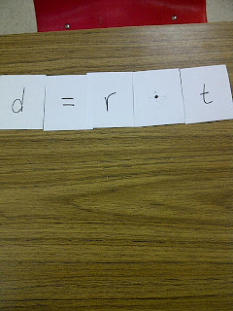
Choose a variable to solve for. I chose to solve for r. Remember, the back of the operator has it's inverse operation, so you would have this:
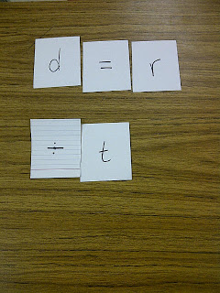
﻿
And finally:
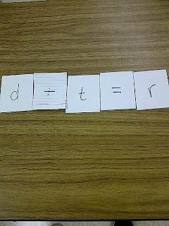
﻿
So I thought, maybe this is too easy. So I tried it with converting Celcius to Farenheit.
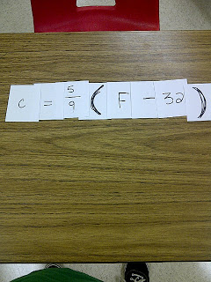
﻿
For fractions, use reciprocals on the back:
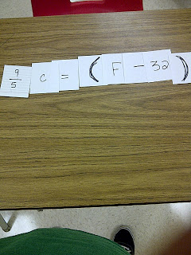
﻿

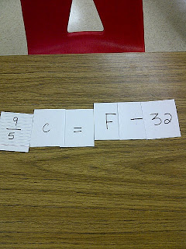

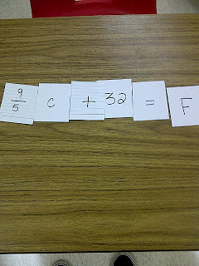

You can create the cards in Word and print onto 3 x 5 notecards (somthing I just discovered!)﻿
﻿
﻿
Posted by Christy at 5:54 PM
Email ThisBlogThis!Share to TwitterShare to FacebookShare to Pinterest

7 comments:
- 
AnnaJuly 30, 2012 at 6:14 PM
What about leaving the backs of the cards blank so that students have to write in the inverse operation or reciprocal themselves? That might be the next step to bridge to solving literal equations on paper.
Reply
- 
ChristyJuly 30, 2012 at 6:16 PM
I was thinking the same thing. Perhaps laminating them so that they can use a dry erase marker to write on them. Thanks for the idea!
Reply
- 
Michelle BurtonJuly 30, 2012 at 11:52 PM
What a great idea! Thanks for sharing. I really find that when they are able to solve these literal equations it means that they truly are starting to grasp solving. At times I'm tempted to introduce these much sooner than I do!
Reply
- 
pamjwilsonJuly 31, 2012 at 9:49 AM
This is VERY similar to one of the Station Activities for Algebra I book - but what I *LOVE* is the inverse operation on the back!!! I've got a set of cards laminated and ready to go for this lesson - but plan to add this simple but AMAZING idea to the back of my operation cards!!! thanks!
Reply
- 
druinJuly 31, 2012 at 1:32 PM
Wow! What a great (and tactile) way to illustrate what is going on! Love it!
Reply
- 
Simplifying RadicalsAugust 11, 2012 at 8:28 AM
This is great! I was just thinking about how difficult literal equations are for students.
Reply
- 
Sue FritzSeptember 20, 2012 at 9:04 AM
The problem I see is that this doesn't reinforce the concept of balancing equations. I like the idea, what can we do to show that you're actually doing the inverse operation to both sides of the equation?
Reply

